**Question 03**

**Code**

clear

clc

time_data=0:12;

depth_data=[0,2,5,8,15,28,32,49,57,68,110,109,130];

vel_F=[];

n=length(time_data);

for i=1:n-1

vel_F(i)=depth_data(i+1)-depth_data(i);

end

vel_B=[];

for i=2:n

vel_B(i-1)=depth_data(i)-depth_data(i-1);

end

vel_C=[];

for i=2:n-1

vel_C(i-1)=(depth_data(i+1)-depth_data(i-1))/2;

end

acc_C=[];

for i=2:n-1

acc_C(i-1)=depth_data(i+1)-2*depth_data(i)+depth_data(i-1);

end

acc_B=[];

for i=3:n

acc_B(i-2)=depth_data(i)-2*depth_data(i-1)+depth_data(i-2);

end

acc_F=[];

for i=1:n-2

acc_F(i)=depth_data(i+1)-2*depth_data(i+1)+depth_data(i);

end

disp('Velocity using forward difference is');

disp(vel_F);

disp('Velocity using backward difference is');

disp(vel_B);

disp('Velocity using central difference is');

disp(vel_C);

disp('Acceleration using forward difference is');

disp(acc_F);

disp('Acceleration using backward difference is');

disp(acc_B);

disp('Acceleration using central difference is');

disp(acc_C);

**Output**

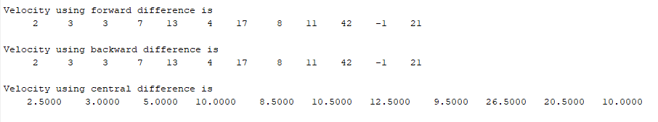

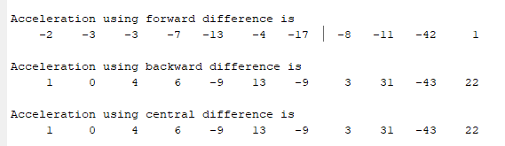

**Question 04**

**Code**

clc

clear all;

close all

f=@(x)(-3.8*(x -664)^2 -8.6*(x -664) -500-664);

a=f(0);

f=@(x)(-3.8*(x -664)^2 -8.6*(x -664) -800-664);

b=f(0);

c =4;

limits_iteration=100;

iteration_rect = sym(zeros(1,limits_iteration));

iteration_trapz = sym(zeros(1,limits_iteration));

iteration_simpshon = sym(zeros(1,limits_iteration));

for i = 1:limits_iteration

dx = (b-a)/i;

sum_rect = 0;

for p = 1:i

X = a + p*(dx)-(dx/2);

Y = sqrt(((X^2)-(c^2)))/X;

sum_rect = sum_rect + Y*dx;

end

iteration_rect(i) = sum_rect;

% Trap Method

dx = (b-a)/(i-1);

sum_trpz = 0;

for q = 1:i

X = a + ((q-1)*dx);

Y = sqrt(((X^2)-(c^2)))/X;

if (q == 0)||(q == i)

coeff = 0.5;

else

coeff = 1;

end

sum_trpz = sum_trpz + (coeff*Y*dx);

end

iteration_trapz(i) = sum_trpz;

sum_simpson = 0;

for r = 1:i

X = a + ((r-1)*dx);

Y = sqrt(((X^2)-(c^2)))/X;

if (mod(r,2) == 0)

coeff = 4;

else

coeff = 2;

end

if (r == 0)||(r == i)

coeff = 1;

end

sum_simpson = sum_simpson + (coeff*Y*dx*(1/3));

end

iteration_simpshon(i) = sum_simpson;

end

plot(iteration_rect)

hold on;

plot(iteration_trapz);

hold on;

plot(iteration_simpshon);

hold on

legend('Rectangle Method','Trapeziod','Simpson Rule');

title('Error in surface area ');

xlabel('Iteration');

ylabel ('Error');

grid on;

**Output**

